Literature Review

Multidisciplinary Management Approaches for Hydrocephalus and Cleft Lip Palate in Pediatric Patients

1 1 1 1
Angeline Musmarihan , Selfiana Tasya , Chika Auliya , Lisa Rosyelina

- Fakultas Kedokteran Gigi, Universitas Muhammadiyah Surabaya

Abstract

Hydrocephalus and cleft lip and palate (CLP) are congenital abnormalities that significantly impact a child's health and development. Hydrocephalus results from impaired cerebrospinal fluid circulation, which increases intracranial pressure and can lead to brain damage. CLP is caused by a failure of facial tissue fusion during the embryonic period, which disrupts speech, eating, and facial aesthetics. This study used a qualitative descriptive literature review method to describe the multidisciplinary management of both conditions.
The review results indicate that hydrocephalus is generally treated with a ventriculoperitoneal shunt or endoscopic third ventriculostomy, while CLP requires surgical correction (cheiloplasty and palatoplasty) accompanied by speech therapy, orthodontics, and psychological support. It can be concluded that interdisciplinary collaboration is crucial for improving clinical outcomes and patient quality of life. Further research is recommended to assess the long-term effectiveness and the relationship between genetic and environmental factors in the occurrence of these two disorders.

Keywords : Hydrocephalus, cleft lip and palate, children, multidisciplinary, management
Correspondence : chikaauliya5454@gmail.com

INTRODUCTION
Hydrocephalus is a serious neurological disorder characterized by an increase in cerebrospinal fluid (CSF) volume within the brain's ventricular system, resulting in increased intracranial pressure. Normal intracranial pressure ranges from 7–15 mmHg, and increased pressure can cause symptoms such as head enlargement, seizures, neurological deficits, headaches, fever, and paralysis, all of which impact the patient's quality of life. This condition is not a single disease, but rather the end result of a wide range of pathological processes, both congenital and acquired (Manik, Putra, Atifah, 2024). Classification of hydrocephalus involves two main types: obstructive (non-communicating) hydrocephalus and communicating hydrocephalus, depending on whether or not there is a connection between the ventricular system and the subarachnoid space.
Obstructive hydrocephalus occurs due to obstruction of CSF flow within the ventricular system or its channels leading to the subarachnoid space, while communicating hydrocephalus involves impaired CSF absorption even though the ventricular pathway remains open. The global incidence of congenital hydrocephalus reaches 3-4 per 1,000 live births with an overall prevalence of 84.7 per 100,000 population (Manik, Putra, Atifah, 2024).
In Indonesia, hydrocephalus accounts for approximately 40–50% of pediatric neurosurgeries. Etiological factors include congenital abnormalities such as aqueductal stenosis of Sylvius and Dandy-Walker malformation, intraventricular hemorrhage in premature infants, intrauterine infections (e.g., Toxoplasma gondii and CMV), genetic abnormalities, alcohol exposure, and exposure to heavy metals such as tungsten and chromium, which can damage the choroid plexus and brain ependyma. Early diagnosis and prompt surgical management are crucial, as delays in treatment can lead to permanent disability or death (Manik, Putra, Atifah, 2024).
Cleft lip and palate is one of the most common congenital orofacial abnormalities, characterized by failure of the maxillary and nasal processes to fuse during embryogenesis, typically occurring between the 5th and 9th weeks of gestation. This disorder can be a cleft lip, a cleft palate, or a combination of both (cleft lip and palate/CLP). Globally, the incidence of this disorder ranges from 1 in 600 to 1 in 800

live births, with CLP being more common in males and CP being more common in females. In Indonesia, the incidence rate reaches 0.49–1.23 per 1,000 live births, with approximately 7,500 new cases each year, representing 2.4% of all congenital abnormalities (Nuha Afifa Khairotin, 2025).
Etiologically, cleft lip and palate are multifactorial, encompassing genetic factors, maternal nutritional deficiencies (especially folic acid), hormonal disorders, exposure to teratogenic substances, intrauterine infections, and environmental factors such as the use of certain medications during pregnancy. Clinical manifestations include difficulty breastfeeding, speech disorders (hypernasality due to levator veli palatini muscle dysfunction), recurrent middle ear infections, hearing loss, and psychosocial impacts such as low self-confidence and limited social interaction (Nuha Afifa Khairotin, 2025; Dewi Putu Suliaswati, 2019).
Management of cleft lip and palate requires a multidisciplinary approach involving pediatricians, oral and maxillofacial surgeons, orthodontists, speech therapists, and nutritionists. The main goals of treatment include restoring the anatomical and physiological functions of the oral cavity and improving facial aesthetics through primary surgical procedures such as cheiloplasty for lip repair and palatoplasty for palate closure, followed by long-term rehabilitative therapy to support optimal growth, speech development, and masticatory function (Nuha Afifa Khairotin, 2025; Dewi Putu Suliaswati, 2019).

LITERATURE REVIEW

Definition of Hydrocephalus
Hydrocephalus is defined as a pathological accumulation of cerebrospinal fluid (CSF) within the ventricular system of the brain, resulting in progressive ventricular enlargement and increased intracranial pressure (ICP). This occurs due to disturbances in CSF production, circulation, or absorption, ultimately causing compression and dysfunction of the surrounding neural (Koleva and De Yesus, 2025). Hydrocephalus is considered a clinical syndrome rather than a single disease entity because it represents the final common pathway of multiple neurological disorders that disrupt normal CSF dynamics (Yousaf et al., 2018). The term derives from the Greek words hydro (water)

Jurnal Kedokteran Gigi An-Najjari

and kephalos (head), historically described more than 2,000 years ago (Permana, 2018). Hydrocephalus may be categorized into communicating and non-communicating (obstructive) types depending on whether CSF flow is blocked within the ventricular system (Koleva and De Yesus, 2025). Communicating hydrocephalus results from impaired CSF absorption at the arachnoid granulations, whereas non-communicating hydrocephalus occurs due to structural blockage at sites such as the aqueduct of Sylvius or the foramen of Monro (Permana, 2018). The condition can be congenital or acquired, with acquired forms commonly resulting from intraventricular hemorrhage, infection, trauma, tumors, or other intracranial pathologies (Koleva and De Yesus, 2025). If left untreated, sustained elevation of ICP can progress to cerebral herniation, permanent neurological injury, and death (Yousaf et al., 2018).
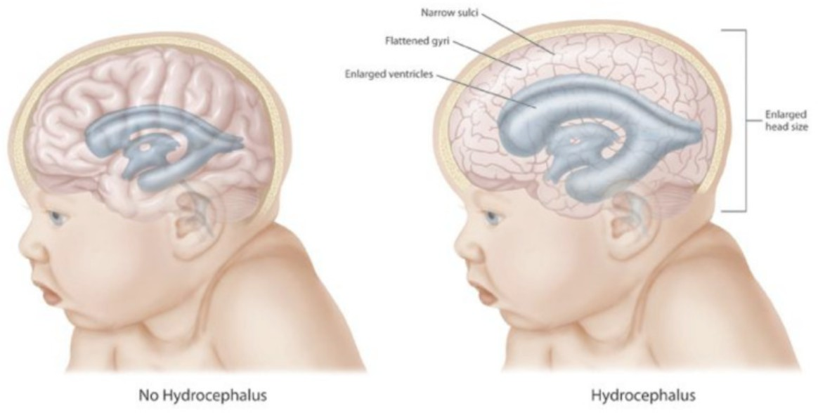

Figure 1. Hydrocephalus (StatPearls Publishing LLC., 2025)

Definition of Cleft Lip Palate

Cleft lip and palate (CLP) is defined as a congenital craniofacial anomaly resulting from the failure of fusion between the maxillary and frontonasal prominences during embryogenesis (Chaudhary, 2022). This defect may involve the lip, alveolus, hard palate, soft palate, or a combination of these structures, presenting bilaterally or unilaterally (Khairotin, 2025). CLP is considered a major global craniofacial anomaly due to its functional and psychosocial consequences for affected children (Chaudhary, 2022). The condition affects orofacial form and function, particularly feeding, speech, and facial aesthetics (Dewi, 2019).

Epidemiology

Hydrocephalus occurs across all age groups, but the burden is highest in infants and older adults due to their increased vulnerability to CSF flow disturbances (Koleva and De Yesus, 2025). Global estimates indicate an incidence of approximately 3 per 1,000 live births, making it one of the most common congenital neurological disorders worldwide (Permana, 2018). The epidemiological pattern varies by region, with developing countries experiencing higher rates because of increased neonatal infections, inadequate perinatal care, and greater prevalence of post-hemorrhagic hydrocephalus in premature infants (Anwar et al., 2024). In adults, the incidence of normal-pressure hydrocephalus rises significantly after 60 years of age and contributes substantially to morbidity related to gait instability and cognitive decline (Koleva and De Yesus, 2025). These demographic patterns underscore the broad clinical impact of hydrocephalus across populations and health-care systems (Anwar et al., 2024).
The global prevalence of CLP ranges between 1:600 and 1:800 live births, making it one of the most frequently encountered congenital craniofacial anomalies (Khairotin, 2025). Ethnic variations are significant, with Asian populations showing higher rates and African populations showing the lowest reported incidences (Chaudhary, 2022). Regional differences are influenced by genetic predisposition, environmental exposures, and variations in maternal health (Chaudhary, 2022). In Indonesia, the prevalence is estimated at up to 1.23 per 1,000 live births, amounting to thousands of new cases yearly (Khairotin, 2025).
Epidemiological patterns also reveal sex-linked tendencies, where cleft lip with or without cleft palate is more common in males, while isolated cleft palate is more common in females (Chaudhary, 2022). The distribution of unilateral versus bilateral clefts shows a clear dominance of unilateral defects, particularly on the left side in approximately 70% of cases (Chaudhary, 2022). Syndromic associations occur in nearly half of CLP cases, especially conditions such as Pierre Robin Sequence and Apert Syndrome (Chaudhary, 2022). These epidemiological insights underscore the need for robust public health surveillance and early referral systems in pediatric care settings (Allareddy et al., 2021).

Etiology

Hydrocephalus arises from a wide range of congenital and acquired causes, each altering CSF physiology through different mechanisms. Congenital hydrocephalus frequently results from neural tube defects, aqueductal stenosis, Dandy–Walker malformation, or Arnold–Chiari malformations, all of which disrupt normal CSF pathways during early brain development (Permana, 2018). Genetic contributions, including mutations in L1CAM, CCDC88C, and AP1S2, have been identified as significant factors influencing CSF transport defects and ventricular enlargement (Yousaf et al., 2018). Acquired hydrocephalus may develop secondary to intraventricular hemorrhage, bacterial meningitis, traumatic brain injury, brain tumors, or subarachnoid hemorrhage, each of which interferes with CSF absorption or obstructs ventricular flow (Koleva and De Yesus, 2025). Tumors such as craniopharyngiomas, ependymomas, and choroid plexus papillomas can directly impede CSF movement through the ventricular pathways and remain among the most common structural causes of obstructive hydrocephalus (Anwar et al., 2024). These diverse etiological pathways reflect the complexity of CSF regulation in maintaining intracranial homeostasis (Yousaf et al., 2018).
CLP originates from disrupted embryologic fusion processes occurring between the 4th and 12th week of gestation, depending on whether the lip or palate is affected (Chaudhary, 2022). Genetic factors play a major role, with mutations in key genes such as IRF6, TFAP2A, and GRHL3 impairing neural crest cell migration and mesenchymal proliferation (Chaudhary, 2022). These disruptions lead to incomplete fusion of facial processes, resulting in clefts that span varying depths and anatomical locations (Dewi, 2019). The resulting defect compromises both anatomical integrity and functional stability of the lip and palate (Nugraha et al., 2023).

Environmental factors amplify the risk of CLP by interacting with genetic vulnerabilities, particularly maternal smoking, alcohol consumption, viral infections, nutritional deficiencies, and teratogenic medications (Nugraha et al., 2023). These exposures disrupt embryonic cellular signaling pathways and impair normal facial fusion during critical developmental windows (Chaudhary, 2022). The structural defects

that occur subsequently impair feeding, phonation, velopharyngeal closure, and middle-ear ventilation (Dewi, 2019). As a result, CLP presents a complex interplay of genetic, environmental, and developmental factors leading to long-term functional consequences (Allareddy et al., 2021).

Pathophysiology

CSF is produced by the choroid plexus at a steady rate of approximately 0.35 mL/min, amounting to roughly 500 mL daily, while the total intracranial CSF volume remains between 120 and 150 mL in adults (Permana, 2018). The physiological circulation of CSF follows a defined route from the lateral ventricles to the third ventricle, through the aqueduct of Sylvius to the fourth ventricle, and finally into the subarachnoid space for absorption via the arachnoid granulations (Koleva and De Yesus, 2025). Hydrocephalus results when this delicate balance is disrupted by obstruction, impaired absorption, or excessive production. Molecular processes contribute significantly to disease progression, including aquaporin dysregulation affecting water transport, impairment of the glymphatic system which normally facilitates waste clearance, overactivation of NKCC1 leading to increased intracellular ion flux, and neuroinflammatory responses mediated through TLR4 and cytokine signaling (Yousaf et al., 2018). According to the Monro–Kellie doctrine, increases in CSF volume raise intracranial pressure, promoting transependymal CSF migration into periventricular white matter and resulting in tissue stretching, axonal injury, and progressive neurological dysfunction (Permana, 2018). These combined mechanical and molecular mechanisms explain the diverse clinical manifestations observed in hydrocephalus (Yousaf et al., 2018).

Clinical Manifestations

Clinical presentation varies with age, underlying cause, and rate of CSF accumulation. Infants often present with rapidly increasing head circumference, macrocephaly, bulging anterior fontanelle, scalp vein distension, irritability, poor feeding, recurrent vomiting, and the classical “sunset eye sign” due to pressure on the dorsal midbrain (Permana, 2018). In older children and adults, symptoms reflect increased intracranial pressure and white matter injury, manifesting as headache,

nausea, vomiting, papilledema, gait instability, visual disturbances, and cognitive decline. Normal-pressure hydrocephalus presents distinctly, with Hakim’s triad of gait disturbance, urinary incontinence, and cognitive impairment, frequently complicating diagnosis because ICP may remain within normal limits (Koleva and De Yesus, 2025). Progressive hydrocephalus, if untreated, can lead to long-term neurological deterioration, including motor deficits, seizures, developmental delay, or cognitive regression (Anwar et al., 2024).
Infants with CLP typically exhibit feeding difficulties due to an inability to create adequate intraoral pressure, leading to poor growth and nasal regurgitation (Khairotin, 2025) . Speech impairments—especially hypernasality and articulation errors—are common due to velopharyngeal insufficiency and the malposition of palatal musculature (Dewi, 2019). Recurrent otitis media and conductive hearing loss arise from Eustachian tube dysfunction resulting from palatal muscle defects (Chaudhary, 2022). These complications can significantly affect early childhood communication and overall development (Allareddy et al., 2021).

Dentally, CLP patients frequently present with hypoplastic enamel, microdontia, ectopic eruptions, and missing or malformed teeth near the cleft region (Chaudhary, 2022). Malocclusions, including crossbites and anterior open bites, often appear due to maxillary growth disturbances and disrupted alveolar anatomy (Gandedkar et al., 2021). Facial asymmetry, nasal deformities, and maxillary retrusion further contribute to functional and aesthetic concerns (Eldesouky & Elbarbary, 2023). Psychosocial issues such as low self-esteem and social stigma may develop without adequate support, impacting mental health and quality of life (Allareddy et al., 2021).

Diagnostic Evaluation

Diagnosis integrates clinical assessment with neuroimaging modalities to evaluate ventricular size and CSF dynamics. In infants with open fontanelles, cranial ultrasonography offers a rapid, noninvasive method to detect ventricular dilation (Permana, 2018). CT scanning is the preferred tool in acute and emergency settings because it rapidly identifies ventricular enlargement and associated complications such as hemorrhage (Koleva and De Yesus, 2025). MRI provides superior soft-tissue contrast

and is crucial for detecting posterior fossa abnormalities, aqueductal stenosis, and congenital malformations, making it essential for evaluating suspected obstructive hydrocephalus (Anwar et al., 2024). Cine phase-contrast MRI enables assessment of CSF flow patterns and can help predict therapeutic response, especially in cases of normal-pressure hydrocephalus (Yousaf et al., 2018). Together, these diagnostic tools support accurate determination of etiology and guide appropriate management (Koleva and De Yesus, 2025).
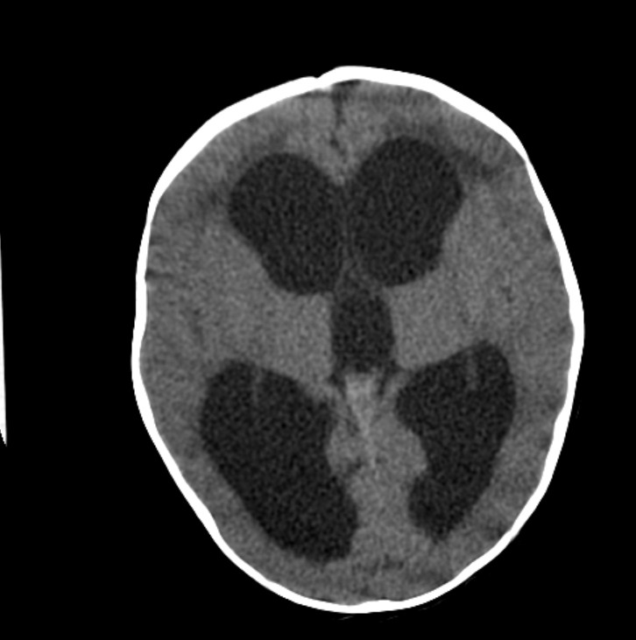

Figure 2. Hydrocephalus Head CT (StatPearls Publishing LLC., 2025)
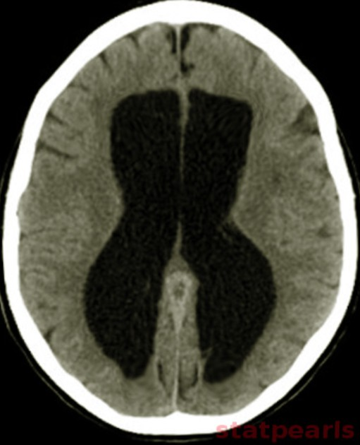
Figure 3. Normal pressure hydrocephalus (StatPearls Publishing LLC., 2025)

Diagnosis at birth relies primarily on visual inspection of the lip, alveolar arch, and palate, allowing immediate referral for specialized care (Khairotin, 2025). Prenatal ultrasound is effective at detecting cleft lip but remains limited in identifying isolated cleft palate due to its posterior location (Wilkes et al., 2023). Further evaluation by

pediatricians, dentists, ENT specialists, and speech therapists is crucial to establish the extent of structural and functional impairment (Dewi, 2019). Early detection enhances care coordination and improves long-term outcomes (Allareddy et al., 2021).

Audiological testing is essential due to the high incidence of conductive hearing loss and middle-ear effusion in CLP patients (Chaudhary, 2022). Imaging modalities—including CT or MRI—may be used in cases where anatomical complexity or syndromic involvement is suspected (Dewi, 2019). Nasoendoscopy and videofluoroscopy can assess velopharyngeal function in children with persistent speech problems after palatal repair (Chaudhary, 2022). These diagnostic steps help determine appropriate timing and planning of surgical and rehabilitative interventions (Gandedkar et al., 2021).

Management

Medical therapy plays a limited role, though acetazolamide and furosemide may temporarily reduce CSF production by inhibiting carbonic anhydrase activity in the choroid plexus (Permana, 2018). Surgical intervention remains the cornerstone of treatment. Ventriculoperitoneal (VP) shunt placement is the most widely used method for long-term CSF diversion and is considered the standard of care in most settings (Koleva and De Yesus, 2025). When VP shunting is not feasible, ventriculoatrial or ventriculopleural shunts are viable alternatives (Permana, 2018). Endoscopic third ventriculostomy (ETV) provides a physiological solution by creating an opening in the floor of the third ventricle to bypass obstructed pathways, offering significant benefit in obstructive hydrocephalus such as aqueductal stenosis (Anwar et al., 2024). Combining ETV with choroid plexus cauterization (ETV-CPC) has demonstrated improved outcomes in infants and in low-resource environments where shunt complications are more frequent (Yousaf et al., 2018). Choice of intervention depends on etiology, patient age, and availability of neurosurgical expertise (Koleva and De Yesus, 2025).
Management of CLP is fundamentally multidisciplinary, beginning with primary surgeries such as cheiloplasty at 3–6 months to reconstruct the lip and palatoplasty at 9–12 months to restore palatal function (Chaudhary, 2022). Presurgical orthopedic therapy such as nasoalveolar molding (NAM) reduces cleft width and improves nasal

symmetry, enhancing surgical outcomes (Ma et al., 2021). Alveolar bone grafting—traditionally using iliac crest bone—restores alveolar continuity and supports the eruption of permanent teeth (Nugraha et al., 2023). Innovations such as β-TCP biomaterials offer a promising alternative with reduced donor-site morbidity (Nugraha et al., 2023).

Long-term management involves orthodontic treatment to correct malocclusion and guide maxillofacial growth (Allareddy et al., 2021). Speech therapy is essential for children with velopharyngeal dysfunction to improve articulation and resonance (Dewi, 2019). Prosthodontic appliances such as obturators may be used in infants or in cases where surgical closure is delayed (Gandedkar et al., 2021). Psychological support is crucial to help patients and families address self-image and social challenges arising from facial differences (Allareddy et al., 2021).

Complications

Hydrocephalus management carries substantial risk of complications. Shunt-related problems are common and include proximal or distal obstruction, over-drainage, mechanical malfunction, and infection (Permana, 2018). Shunt infections, occurring in roughly 5 to 8 percent of cases, may lead to meningitis, peritonitis, or systemic sepsis, often necessitating shunt removal and antibiotic therapy (Koleva and De Yesus, 2025). ETV-related complications include hemorrhage, basilar artery injury, CSF leak, and failure of stoma patency, although infection rates remain lower compared to shunt procedures (Anwar et al., 2024). Pediatric patients frequently require multiple shunt revisions across their lifetime as growth and mechanical failure contribute to recurrent malfunction (Yousaf et al., 2018). These complications highlight the need for meticulous long-term follow-up.
Surgical complications may include wound dehiscence, infection, and palatal fistula formation, particularly in wide or syndromic clefts (Dewi, 2019). Persistent velopharyngeal insufficiency may occur even after palatoplasty, resulting in nasal air escape and impaired speech (Chaudhary, 2022). Eustachian tube dysfunction often continues postoperatively, predisposing patients to recurrent otitis media and hearing

loss (Chaudhary, 2022). These complications may necessitate additional surgeries and long-term monitoring (Allareddy et al., 2021).

As children grow, maxillary hypoplasia and midface retrusion may develop, requiring orthodontic intervention or orthognathic surgery in adolescence (Eldesouky & Elbarbary, 2023). Dental crowding, agenesis, and malocclusion are frequent and complicate oral hygiene, potentially increasing caries risk (Chaudhary, 2022). Patients may also experience nasal deformities that affect both function and aesthetics, sometimes requiring secondary rhinoplasty (Eldesouky & Elbarbary, 2023). Psychosocial problems—including anxiety, bullying, and low confidence—are common without continuous psychological and social support (Allareddy et al., 2021).

Prognosis

Prognosis is influenced by the underlying etiology, age at diagnosis, and promptness of intervention (Permana, 2018). Early surgical treatment generally results in significant improvement in neurological function and overall quality of life (Koleva and De Yesus, 2025). However, infants with severe congenital hydrocephalus may continue to experience cognitive and developmental delays despite appropriate management (Anwar et al., 2024). Long-term monitoring is essential because approximately half of shunt failures occur within the first six months following placement, necessitating repeated interventions to maintain CSF regulation (Permana, 2018). The combination of timely diagnosis and appropriate neurosurgical care significantly enhances long-term outcomes across patient populations (Yousaf et al., 2018).

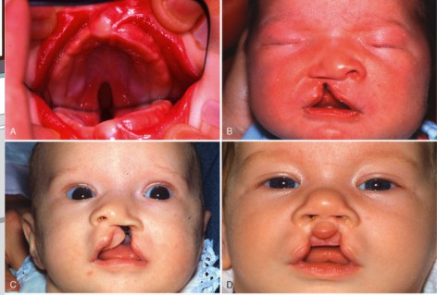
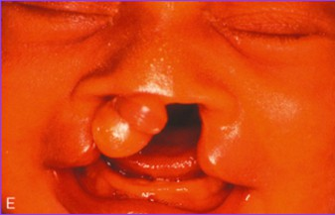
Figure 4. Figure 4. A, Isolated cleft palate (class II). B, Unilateral cleft lip (class II). C, Unilateral complete cleft lip and palate (class III). D, Bilateral incomplete cleft lip and palate (class IV). E, Bilateral complete cleft lip and palate with laterally displaced premaxillary segment (class IV).

When treated early and comprehensively, children with CLP generally achieve good functional outcomes in feeding, speech, and facial appearance (Chaudhary, 2022). Prognosis depends on cleft severity, presence of associated anomalies, timing of surgery, and access to skilled multidisciplinary care (Dewi, 2019). Improvements in surgical techniques, such as refined palatoplasty approaches, have enhanced speech outcomes and reduced postoperative complications (Nugraha et al., 2023). Early and

consistent speech and orthodontic therapy further improve long-term functional results (Allareddy et al., 2021).

Despite advances, CLP patients often require lifelong follow-up due to the dynamic nature of facial growth and dental development (Allareddy et al., 2021). Secondary surgeries—such as alveolar bone graft revisions, velopharyngeal surgery, or orthognathic correction—may be needed during adolescence (Eldesouky & Elbarbary, 2023). Long-term speech outcomes vary, particularly in patients with wide clefts or syndromic involvement (Dewi, 2019). Overall, prognosis improves significantly when patients receive coordinated multidisciplinary care from infancy to adulthood (Chaudhary, 2022).

CONCLUSION
It can be concluded that hydrocephalus and cleft lip and palate (CLP) are congenital abnormalities that have a significant impact on children's health and development, both in terms of neurological aspects and craniofacial function. Hydrocephalus occurs due to impaired cerebrospinal fluid circulation which causes increased intracranial pressure and the risk of permanent brain damage, thus requiring early detection and surgical treatment such as a ventriculoperitoneal shunt or endoscopic third ventriculostomy. Meanwhile, CLP is a disorder caused by the failure of embryonic tissue fusion that impacts speech, eating, facial aesthetics, and the patient's psychological function, so it requires early multidisciplinary treatment through surgical correction, speech therapy, orthodontics, and psychosocial support. Overall, these two conditions require a comprehensive approach with long-term care and further research to improve quality of life, expand access to health services, and better understand the role of genetic and environmental factors in their etiology.

REFERENCES

Allareddy, V., Ross, E. dan Nembhard, W.N. (2021) 'Multidisciplinary care for children with orofacial clefts: a systematic review and meta-analysis', The Cleft Palate-Craniofacial Journal, 58(7), pp. 835-847.

Anwar, F. et al. (2024) ‘Hydrocephalus: An update on latest progress in pathophysiological and therapeutic research’, Biomedicine and Pharmacotherapy, 181(November), p. 117702
Carswell, C. (2023). Idiopathic normal pressure hydrocephalus: historical context and a contemporary guide. Pract Neurol, 23(1), 15–22. doi: 10.1136/pn-2021-003291.
Chaudhary, S. (2022). Cleft Lip and Palate – A Review Article. International Journal of Research and Review, 9(7), 236–243. https://doi.org/10.52403/ijrr.20220727
Dewi, P. S. (2019). Management of Cleft Lip and Palate (Literature Review). Fakultas Kedokteran Gigi Universitas Mahasaraswati Denpasar.
Eldesouky, R. & Elbarbary, A. (2023). Definitive Rhinoplasty and Orthognathic Surgery for Patients with Cleft Lip Palate. Oral Maxillofac Surg Clin North Am, 35(1), 127–137. doi: 10.1016/j.coms.2022.06.011.
Gandedkar, N.H., Raste, Y.A., Kulkarni, A. dan Khandelwal, P. (2021) 'Prosthodontic management of a pediatric patient with cleft lip and palate: a clinical report', Journal of Indian Society of Pedodontics and Preventive Dentistry, 39(2), pp. 209-212.
Kahle, K. T., Klinge, P. M., Koschnitzky, J. E., Kulkarni, A. V., MacAulay, N., Robinson, S., Schiff, S. J., & Strahle, J. M. (2024). Paediatric hydrocephalus. Nat Rev Dis Primers, 10(1), 35. doi: 10.1038/s41572-024-00519-9.
Khairotin, N. A. (2025). Cleft Lip and Palate. Universitas Islam Negeri Sunan Ampel Surabaya.
Khrisna Rangga Permana. (2018). Hidrosefalus dan tatalaksana bedah sarafnya. Cermin Dunia Kedokteran, 45(11), 820–823.
Koleva, M., and De Yesus, O. (2025). Hydrocephalus. In StatPearls [Internet]. Treasure Island (FL): StatPearls Publishing.

Ma, L., Hou, Y., Liu, G., & Zhang, T. (2021). Effectiveness of presurgical orthodontics in cleft lip and palate patients with alveolar bone grafting: A systematic review. J Stomatol Oral Maxillofac Surg, 122(1), 13–17. doi: 10.1016/j.jormas.2020.07.010.
Manik, H. M., Putra, E., & Atifah. (2024). Analisis faktor-faktor penyebab penderita hidrosefalus. Jurnal Kesehatan Lentera Akademika, 6(2), 406–416.
Nugraha, D., Usman, M., Setiabudi, H., Fawzy, A., Al-Fahd, A., & Rahardjo, M. (2023). β-Tricalcium Phosphate as Alveolar Bone Grafting in Cleft Lip/Palate: A Systematic Review. Dentistry Journal, 11(234), 1–18. https://doi.org/10.3390/dj11090234
Pfaff, M. J., Nolan, I. T., Musavi, L., Bertrand, A. A., Alford, J., Krishna, V., Arowojolu, O. A., Zhu, X., & Lee, J. C. (2022). Perioperative Pain Management in Cleft Lip and Palate Surgery: A Systematic Review and Meta-Analysis of Randomized Controlled Studies. Plast Reconstr Surg, 150(1), 145e–156e. doi: 10.1097/PRS.0000000000009231.
Permana, K.R. (2018) ‘Hidrosefalus dan Tatalaksana Bedah Sarafnya’, Cdk-270, 45(11),
pp. 820–823.
Yousaf, M., Parlato, S. R., & Mallucci, C. L. (2018). Hydrocephalus. In P. D. Losty, et al. (Eds.), Rickham’s neonatal surgery (pp. 931–938).
Raybaud, C., & Krishnan, P. (2021). Hydrocephalus in Children: A Neuroradiological Perspective. Neurol India, 69(Suppl), S283–S291. doi: 10.4103/0028-3886.332282.
Slots, J., & Slots, V. (2024). Severe periodontitis and congenital cytomegalovirus: Cleft lip and cleft palate. Periodontol 2000, 96(1), 185–188. doi: 10.1111/prd.12606.
Wilkes, C., Graetz, M., Downie, L., Bethune, M., & Chong, D. (2023). Prenatal diagnosis of cleft lip and/or palate: What do we tell prospective parents? Prenat Diagn, 43(10), 1310–1319. doi: 10.1002/pd.6418.

Yousaf, M., Parlato, S. R., & Mallucci, C. L. (2018). Hydrocephalus. In P. D. Losty, et al. (Eds.), Rickham’s neonatal surgery (pp. 931–938).
Zaksaite, T., Loveday, C., Edginton, T., Spiers, H. J., & Smith, A. D. (2023). Hydrocephalus: A neuropsychological and theoretical primer. Cortex, 160, 67–99. doi: 10.1016/j.cortex.2023.01.001.

